**FPT ACADEMY INTERNATIONAL**



**FPT – APTECH COMPUTER EDUCATION**

**MERCIADO PARK**

|  |  |  |  |
| --- | --- | --- | --- |
| **Center Name** | | FPT – Aptech – HCM2  Address: 590 Cach Mang Thang Tam, District 3, Ho Chi Minh City | |
| **Instructor** |  | Ms. Le Mong Thuy |  |
| **Class** |  | T1.2302.E1 |  |
| **Group** |  | 3 |  |
| **Group members** | | **Name** | **Student ID** |
|  |  | Vo Hong Tan | Student1448252 |
|  |  | Ha Nguyen Nhat Minh | Student1448329 |
|  |  | Pham Dao Phu Qui | Student1457505 |
| **Duration** | Start date | 23rd May 2023 |  |
| End date | 23rd Jun 2023 |  |

**This is to certify that**

**Mr.:**

Vo Hong Tan

Ha Nguyen Nhat Minh

Pham Dao Phu Qui

**has successfully designed & developed**

eProject: Amusement Park website

**Submitted by:**

Vo Hong Tan

**Date of issue:**

**Authorized Signature:**

**Table of Contents**

ACKNOWLEGMENT 3

SYNOSIS 3

PROBLEM DEFINITION 3

CUSTOMER'S REQUIREMENTS SPECIFICATIONS 4

SCOPE OF THE WORK (IN BRIEF) 6

ARCHITECTURE AND DESIGN OF THE SYSTEM 7

DIAGRAM OF THE WEBSITE 8

TASK SHEET REVIEW 1 9

SITE MAP 11

MOCK OF THE WEB SITE 12

1. Homepage 12

2. Zone 13

3. News 14

4. Ticket 15

5. Gallery 16

6. About Us 17

7. Contact Us 18

8. Sign in/Sign Up 19

TASK SHEET REVIEW 2 20

1. Homepage 21

2. Zone 22

3. News 24

4. Ticket 26

5. Gallery 28

6. About Us 29

7. Contact Us 30

8. Sign in/Sign Up 31

JAVASCRIPT DESCRIPTION 33

**1. Slider Javascript** 33

**2. Cart ticket** 34

**3. Contact Us JS** 37

**4. Create Account/Sign-in Javascript** 38

TASK SHEET REVIEW 3 39

# ACKNOWLEGMENT

On behalf of team members. I would like to thank everyone who supported my team to successfully complete this eProject report. Especially, our teacher, she has supported us a lot since we started studying at FPT Aptech. With this eProject, she guided us very meticulously, enthusiastically and strictly. With her guidance, we were able to successfully complete this project. Besides, I also want to thank all the team members, each of whom worked hard to complete the eProject in earnest during the month of working together. Finally, our group would like to say thank you to my classmates and family for sharing and creating for the group the best environment to focus on the project, motivating the members to achieve their goals.

# SYNOSIS

Merciado Amusement park is now prime focus of the city and nation. It is made by Seth groups of companies. The development of this park took 5 years to get their desired finished product. It has became nation pride now. The area of theme park is about 45 acre land. The Management has put all the efforts to keep the attractions operational. The merciado management wants you to develop the website of the park which should include describing all the attraction of the park and also allow the user to book the ticket online.

# PROBLEM DEFINITION

The Web site is to be created based on the following requirements.

1. The home page must be designed with beautiful color combination with all the required links defined properly. Also all the section of the webpage must be in used to avoid the blank space.
2. Different Zones and attraction, Restaurants, Entertainment, Tickets and Prices, Gallery be described in different webpage.
3. Prices value must be show the differences as per the day (like weekend or weekday or family pack).
4. About us, Contact Us, Disclaimer must be included.
5. Creating an account facility can also be added.
6. Dummy procedure for booking the ticket can be added.
7. Sitemap must be added.
8. Navigation of the project must be made smooth.

# CUSTOMER'S REQUIREMENTS SPECIFICATIONS

Client: Merciado Park

**Business/Project Objective:**

The company advertises by distributing the pamphlets, advertising on television and so on. Due to rapid development in internet field, the company decides to launch a website where people will get all the information about the services available with them easily.

The website is to be developed for the Windows Platform using HTML5, JavaScript and Geolocation. The site should work well in all leading browsers including Chrome, IE, Firefox etc.

**Input to the system:**

* Creating an account facility.
* Booking ticket on website.
* Visitor reviews and ratings.

**Output from the system:**

* Display based on: Different Zones and attraction, Restaurants, Entertainment, Tickets and Prices, Gallery...
* Display results for register account.
* Display ticket information by price, days, combo packages...
* Display the map of park.
* Display information at footer: About us, Contact us.

**Process**:

* Validate data input from users.
* Booking ticket.

**Expected delivery date:** 23-June-2023.

**List of deliverables:**

* Document Word, PDF.
* User Guide.
* Source code.

**Hardware/ Software Requirements:**

* **For developer Hardware**
* Intel Pentium 4 processor or higher
* 01 Gigabytes of RAM or higher
* **Software**
* Windows 7 OS or higher
* Adobe Dreamweaver
* Web browsers such as IE, Chrome or Firefox are supporting HTML5, CSS3 and Javascript.

* **◻ For web users Hardware**
* Intel Pentium 4 processor or higher
* 512 Megabytes of RAM or higher
* **Software**
* Windows XP OS or higher

Web browsers such as IE, Chrome or Firefox are supporting HTML5, CSS3 and Javascript.

# SCOPE OF THE WORK (IN BRIEF)

After a long and detailed discussion, our group has decided to create a website contain the following webpages:

1. ***Homepage***: Display events information and introduce Merciado Park.
2. ***Zone*:** Display more introduce park like history, rides and attractions, ...
3. ***News:*** The latest news, history and development of the park.
4. ***Ticket***: Visitor can find information of ticket ( package, days price), procedure for booking the ticket can be added.
5. ***Gallery***: Displays gallery, events, the map of park, restaurants and eateries...
6. ***Contact Us***: Display the address of the company, Map and allow customers to request any information they want to Merciado Park.
7. ***Sign In/ Sign Up***: Allow users sign up or sign in to the website.

# ARCHITECTURE AND DESIGN OF THE SYSTEM

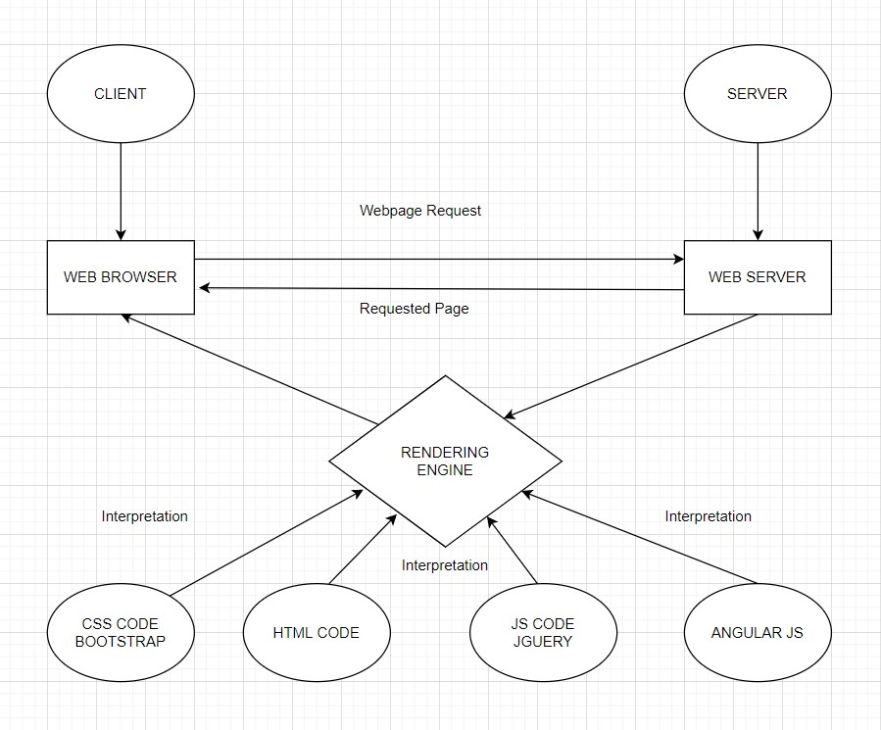

# DIAGRAM OF THE WEBSITE

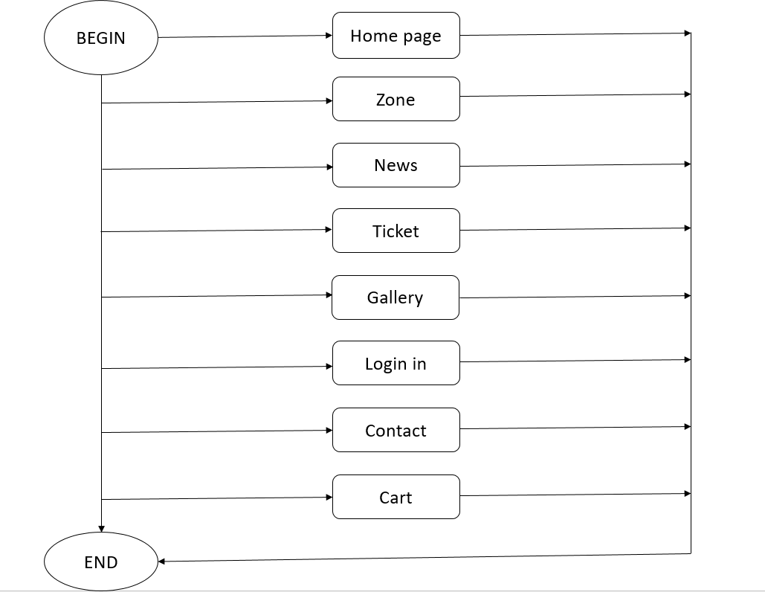

# TASK SHEET REVIEW 1

|  |  |  |  |  |  |  |  |
| --- | --- | --- | --- | --- | --- | --- | --- |
| **Project Ref. No.:**  **eP/Advertisement Portal Management**  **System/01** | | **Project Title:** | **Activity Plan Prepared By:** | **Date of Preparation of Activity Plan:** | | | |
| **Sr.**  **No.** | **Task** | **Actual**  **Start**  **Date** | **Actual Days** | **Team**  **Mate Names** | **Status** |
| 1 | Problem Statement | MERCIADO PARK | Tan+ Minh+ Qui | 25-May-23 | 1 | Tấn+Quí+Minh | Completed |
| 2 | Analysis requirements about the website | 27-May-23 | 1 | Tấn | Completed |
| 3 | The scope of the work (in brief) | 27-May-23 | 1 | Quí | Completed |
| 4 | Architecture and design of the system | 26-May-23 | 1 | Minh-Quí | Completed |
| 5 | Diagram of the website | 29-May-23 | 1 | Minh | Completed |
| 6 | Task Sheet | 29-May-23 | 1 | Tấn | Completed |

|  |  |
| --- | --- |
| **Date:** | |
| Signature of Instructor:  **Ms. Le Mong Thuy** | Signature of Team Leader:  **Vo Hong Tan** |

# SITE MAP

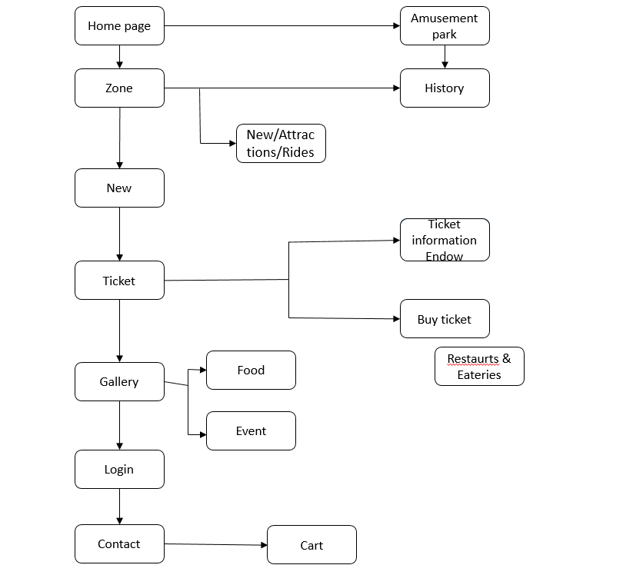

# MOCK OF THE WEB SITE

## Ảnh có chứa văn bản, ảnh chụp màn hình, Phông chữ, hàng Mô tả được tạo tự động1. Homepage

## 2. Zone

## 3. News

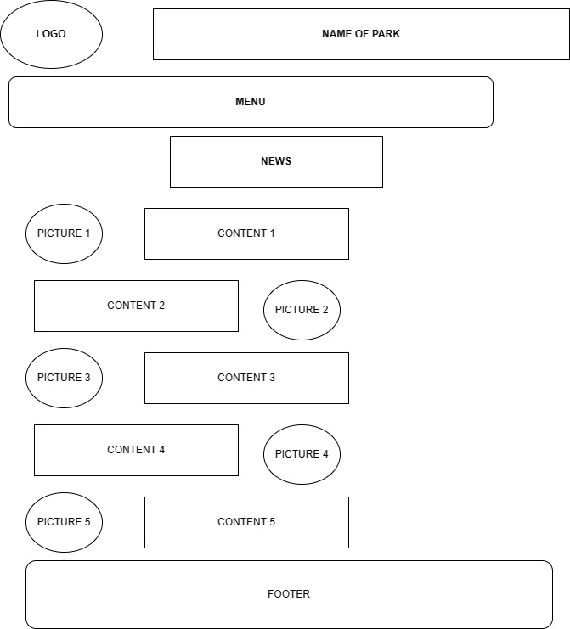

## 4. Ticket

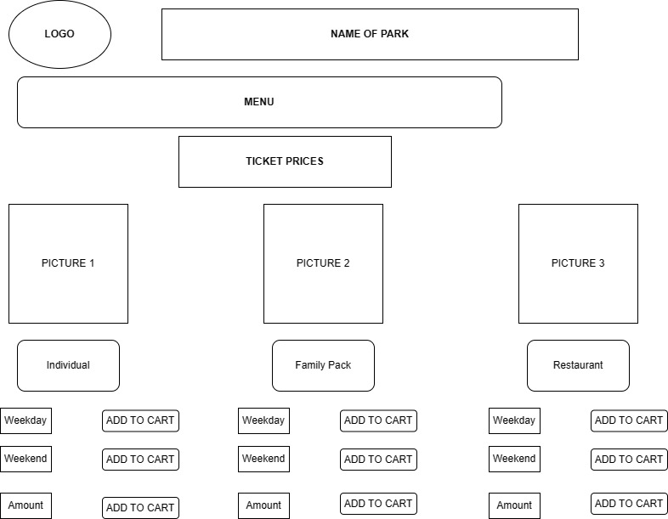

## 5. Gallery

## 6. About Us

## 7. Contact Us

## 8. Sign in/Sign Up

# TASK SHEET REVIEW 2

|  |  |  |  |  |  |  |  |
| --- | --- | --- | --- | --- | --- | --- | --- |
| **Project Ref. No.:**  **eP/Advertisement Portal**  **Management**  **System/01** | | **Project Title:** | **Activity**  **Plan**  **Prepared By:** | **Date of Preparation of Activity Plan:** | | | |
| **No.** | **Task** | **Actual**  **Start**  **Date** | **Actual Days** | **Team**  **Mate**  **Names** | **Status** |
| 1 | Site Map | Merciado Park | Tấn | 25-May-23 | 2 | Tấn | Completed |
| 2 | Mock of the website | 25-May-23 | 2 | Quí+Minh | Completed |
| 3 | Task sheet | 25-May-23 | 2 | Tấn | Completed |

**WEBSITE DESCRIPTION**

## 1. Homepage

1. Description

Home page displays following information:

* + Slide show programs.
  + A welcome slide.
  + Some pictures about Merciado park.

1. 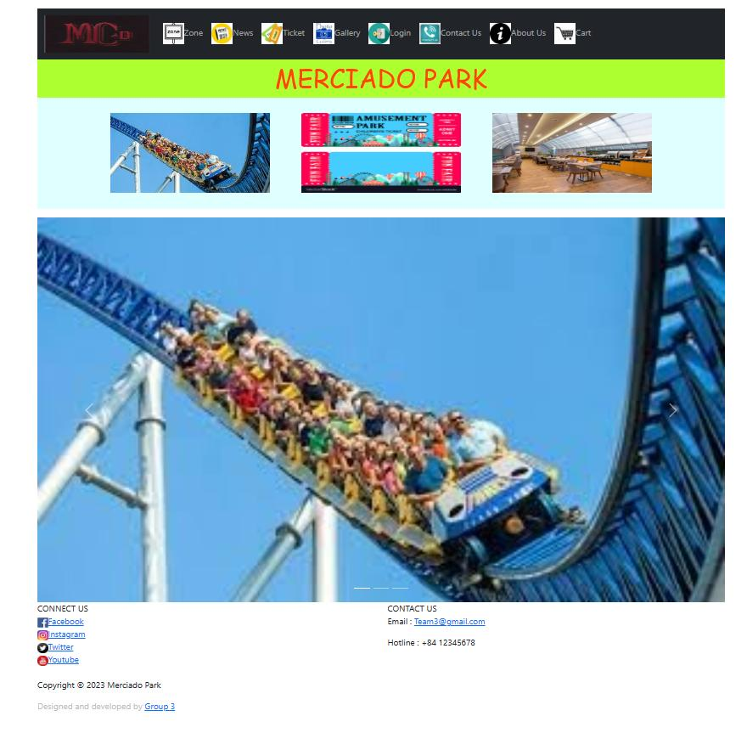Screen shot

## 2. Zone

Division 2 section: Entertainment and Restaurant

1. 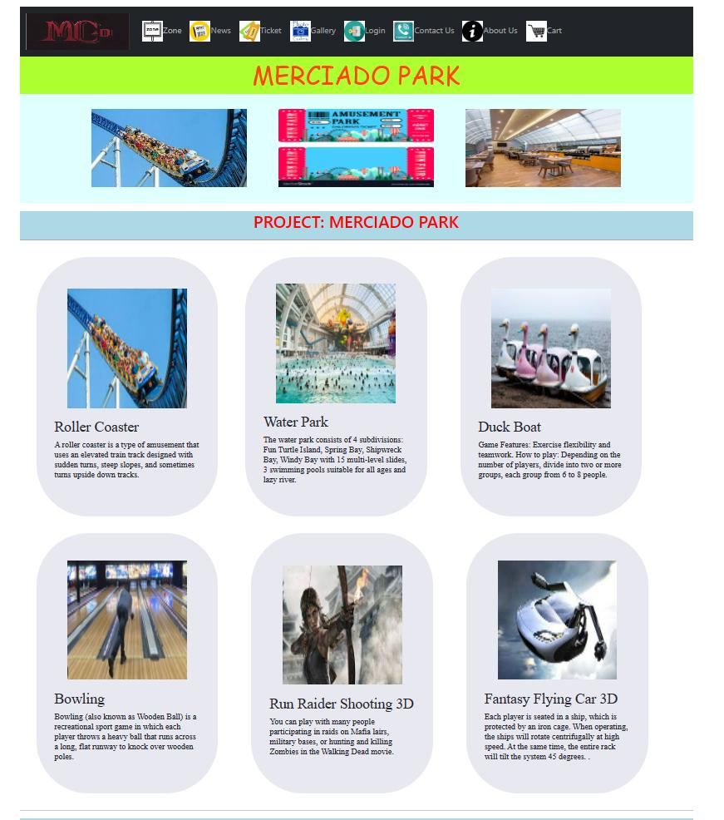Entertainment screen shot: Include games and activity water park.
2. Restaurant zone with Asia Buffet, Europe Buffet and Vegetarian Buffet

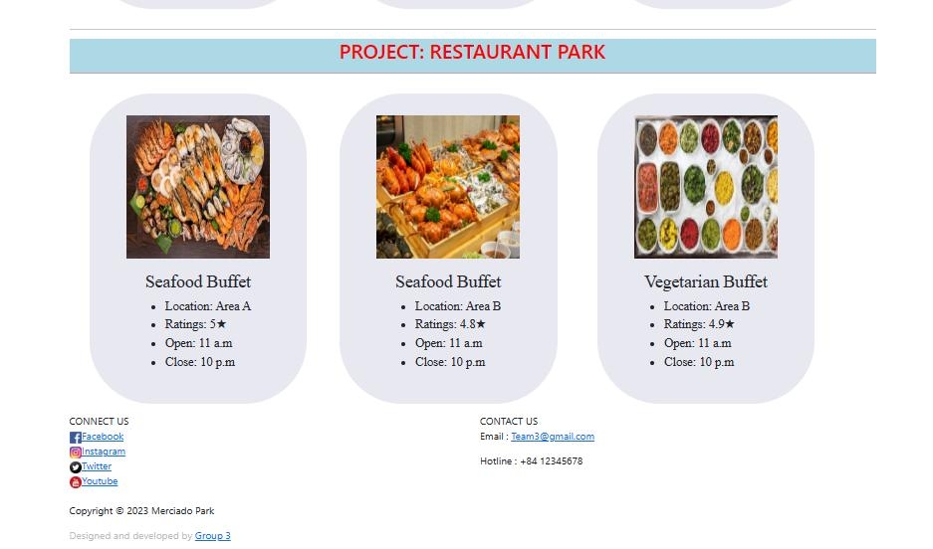

## 3. News

* + Some information about the website.
  + 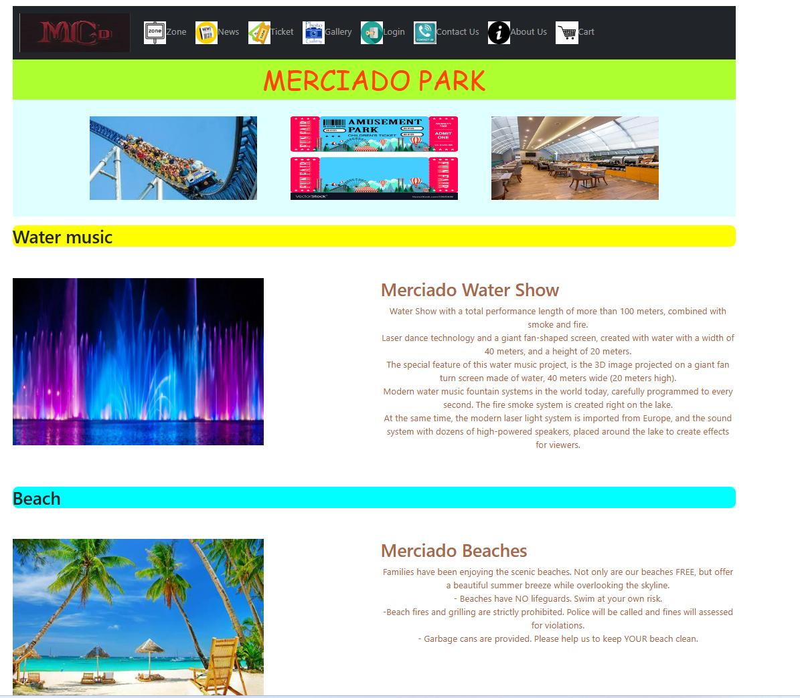News about latest event of park and history.

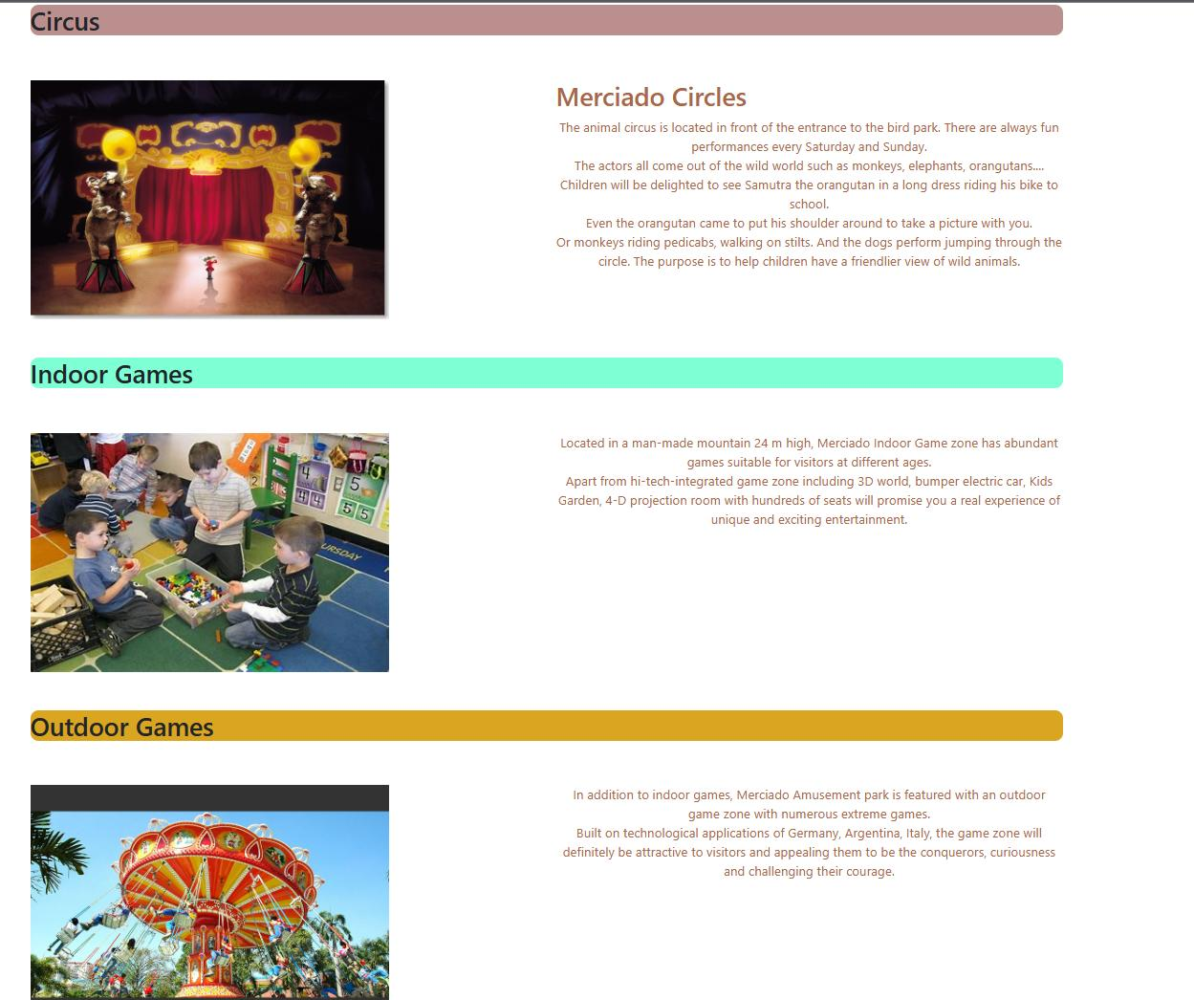

## 4. Ticket

1. Description

The Ticket page displays following information:

* + Information of ticket.
  + Prices about invidiual, family pack and weekend price

1. Screen shot

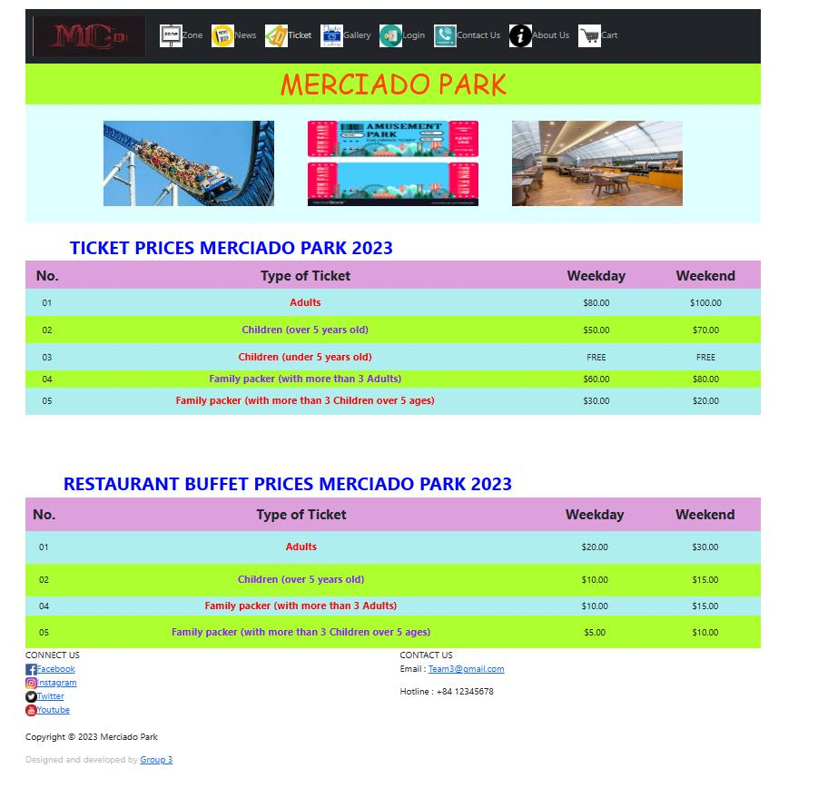

1. **Cart- Screen shot**

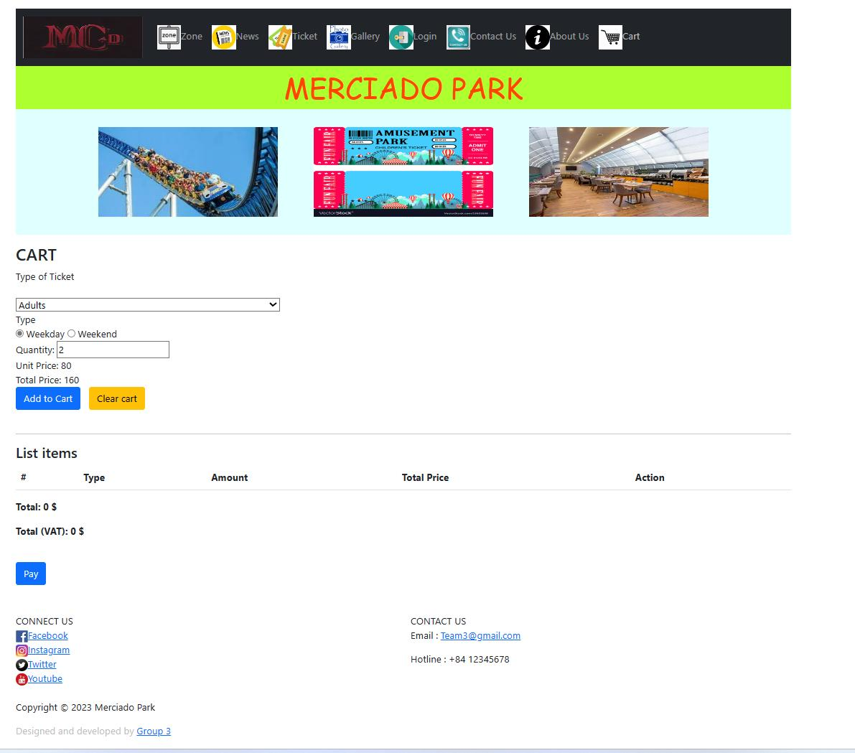

## 5. Gallery

1. Description

- This page displays information: Gallery, events, restaurant and eateries.   
- User can look for our services in this page.

1. Screen shot

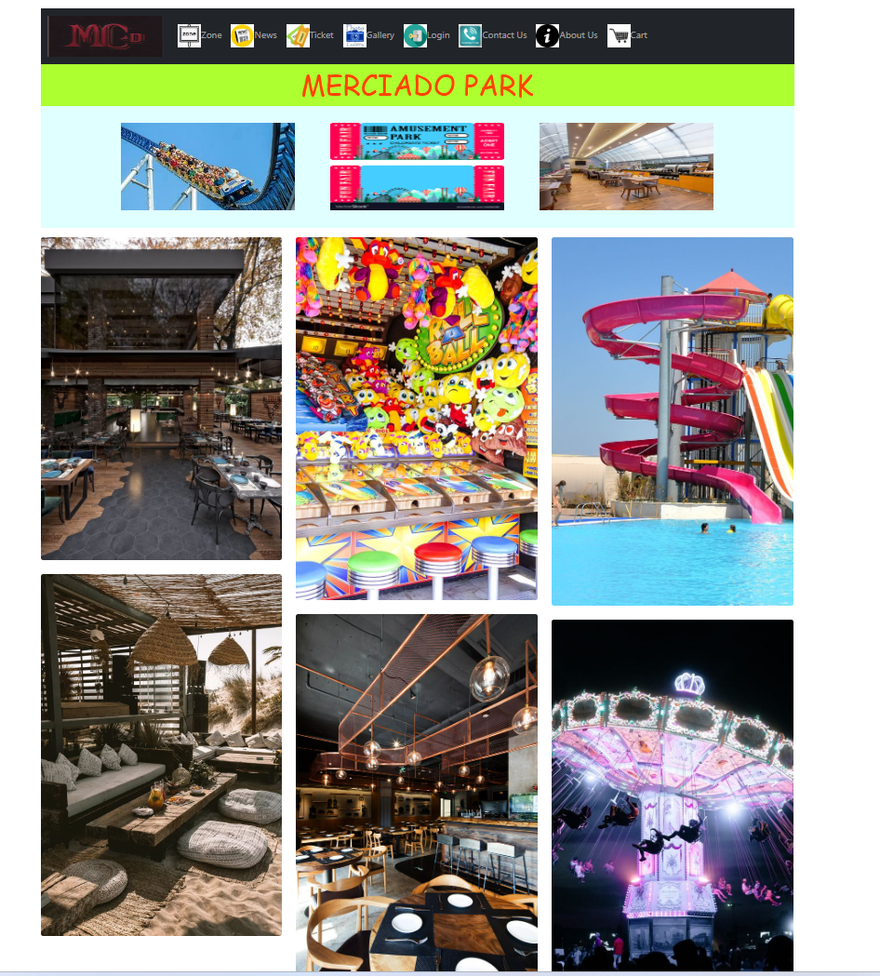

## 6. About Us

1. Description: The About us page displays following information:   
    - Team member infomation.
2. Screen shot

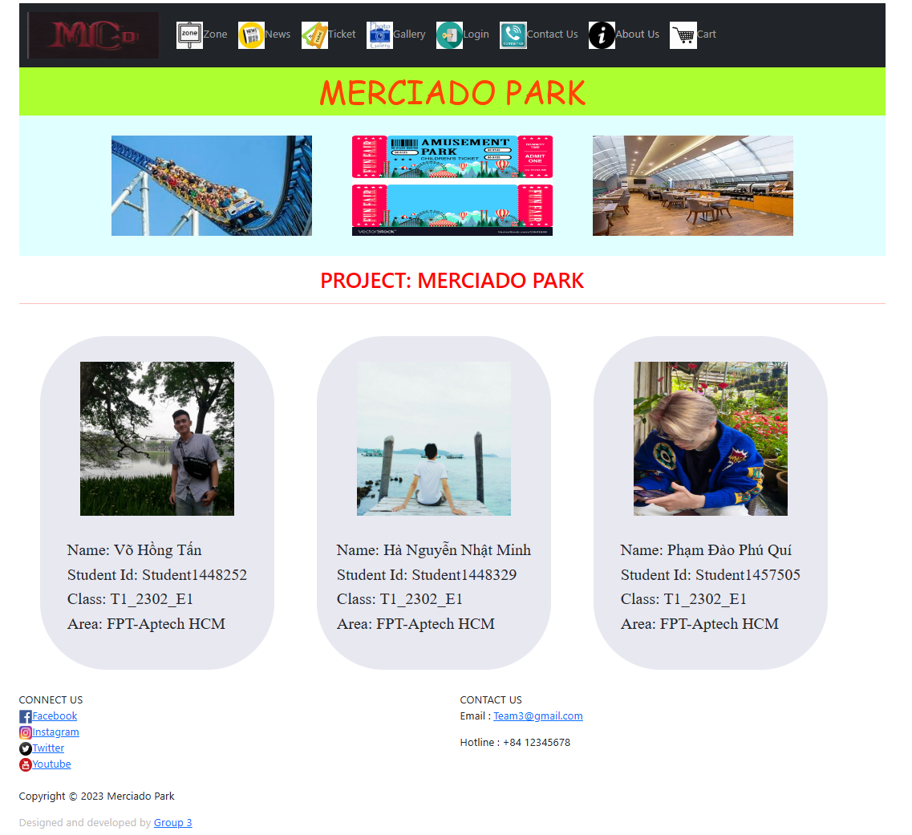

## 7. Contact Us

a) Description: This page displays contact information: location, telephone number, email, a quick contact form for customer, ratings and reviews of customer for us.   
b) Screen shot

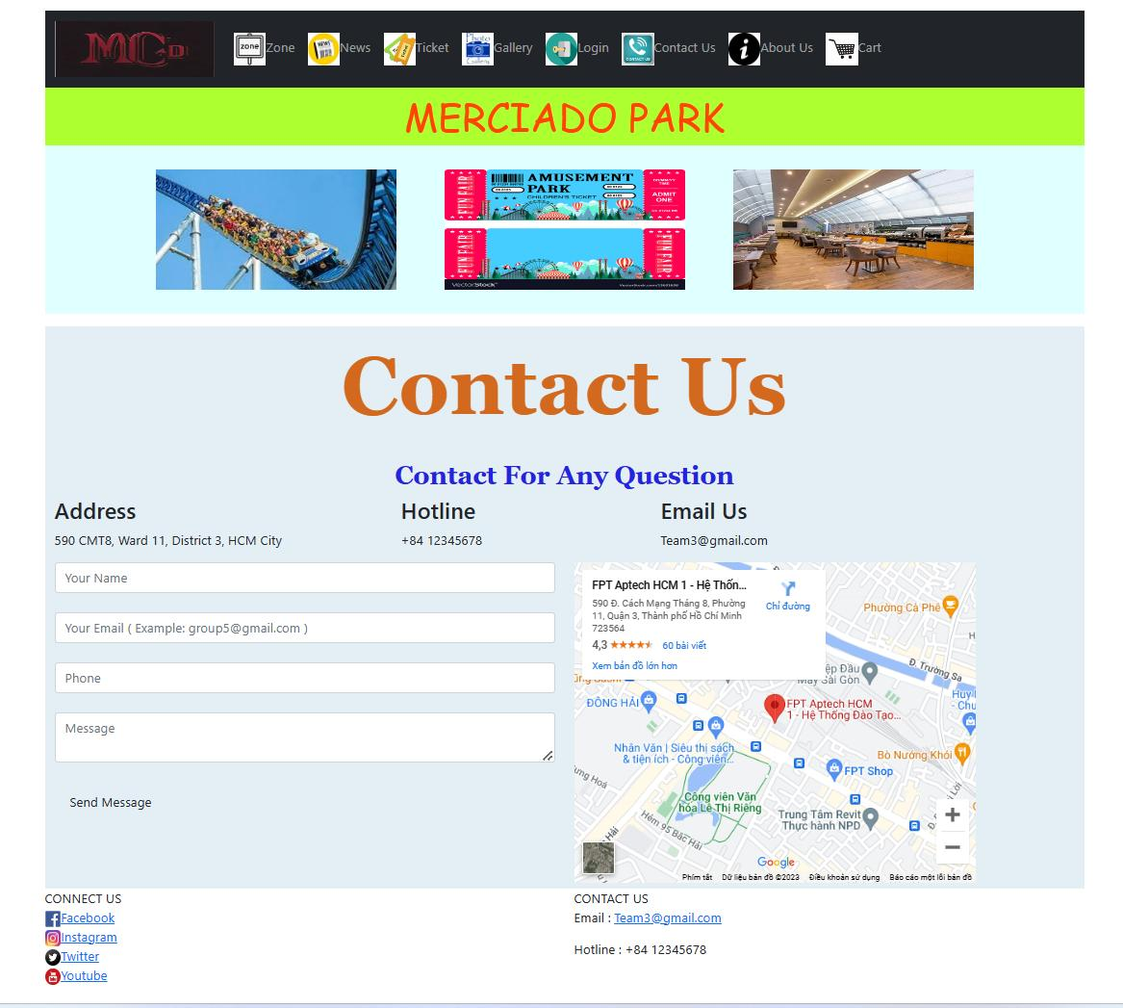

## 8. Sign in/Sign Up

a) Description

- User can login account to do something like booking ticket.

- User can register account if do not have it.

b) Screen shot

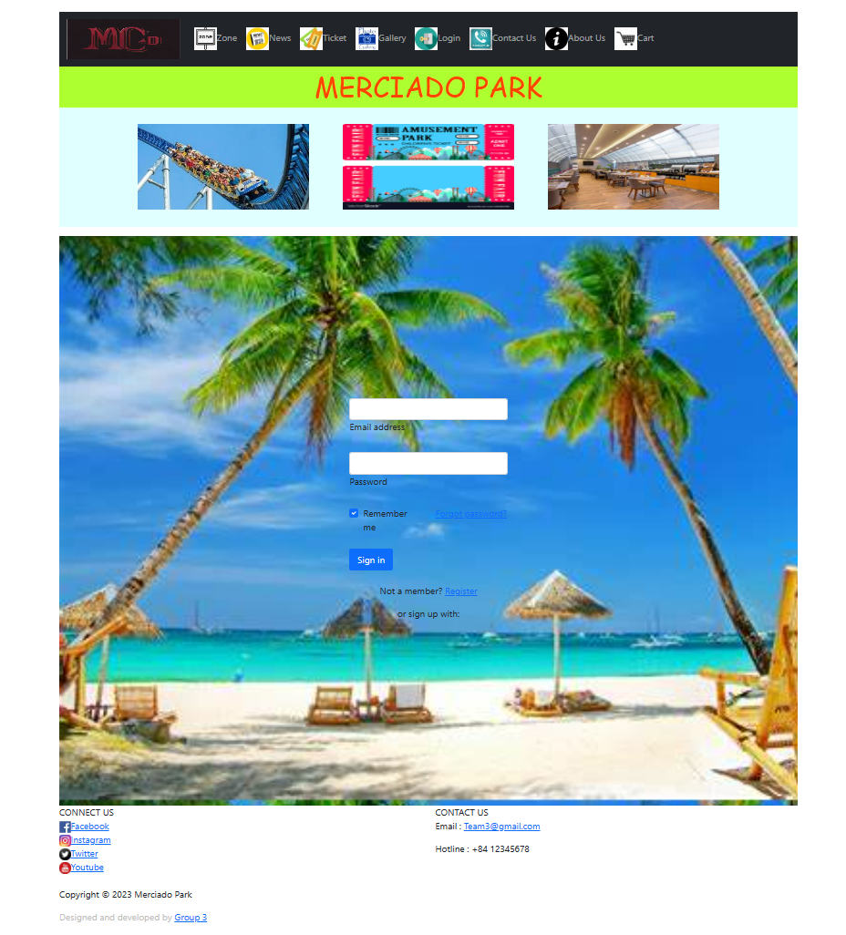

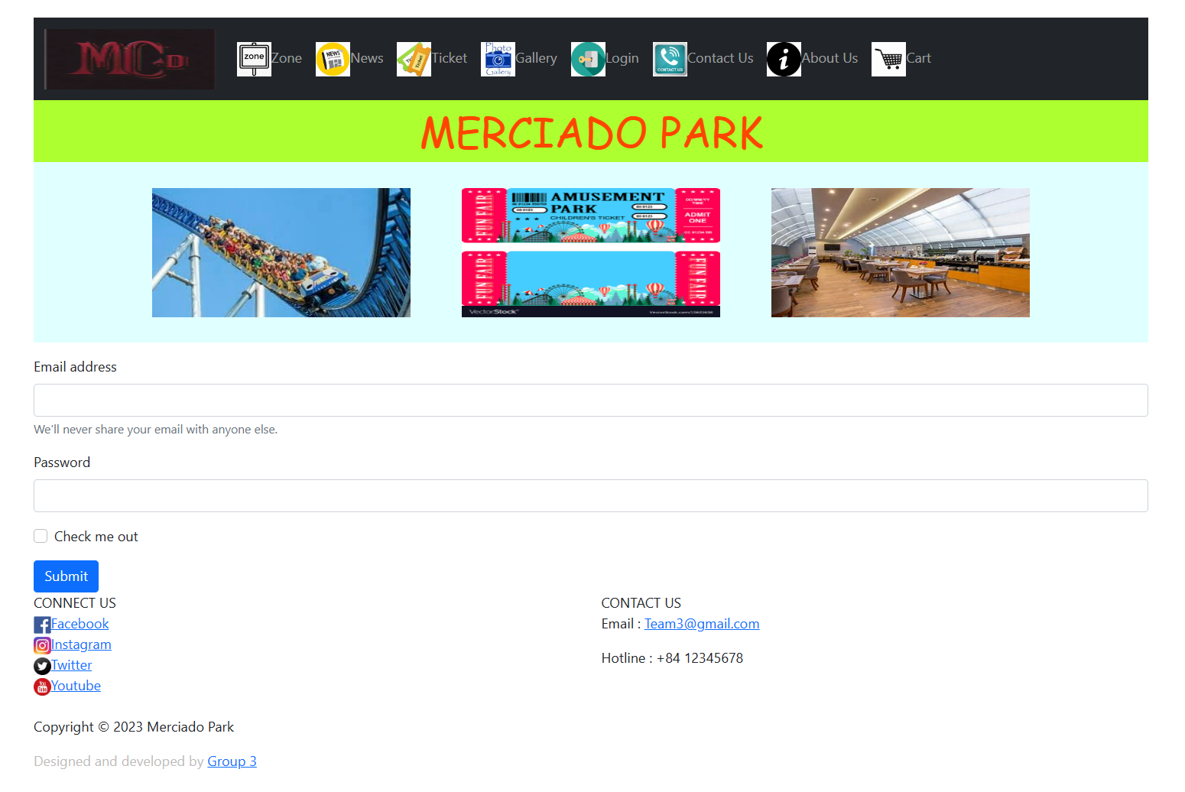

# JAVASCRIPT DESCRIPTION

### **1. Slider Javascript**

a) Description

This script used to slideshow on the website.   
b) Screen shot

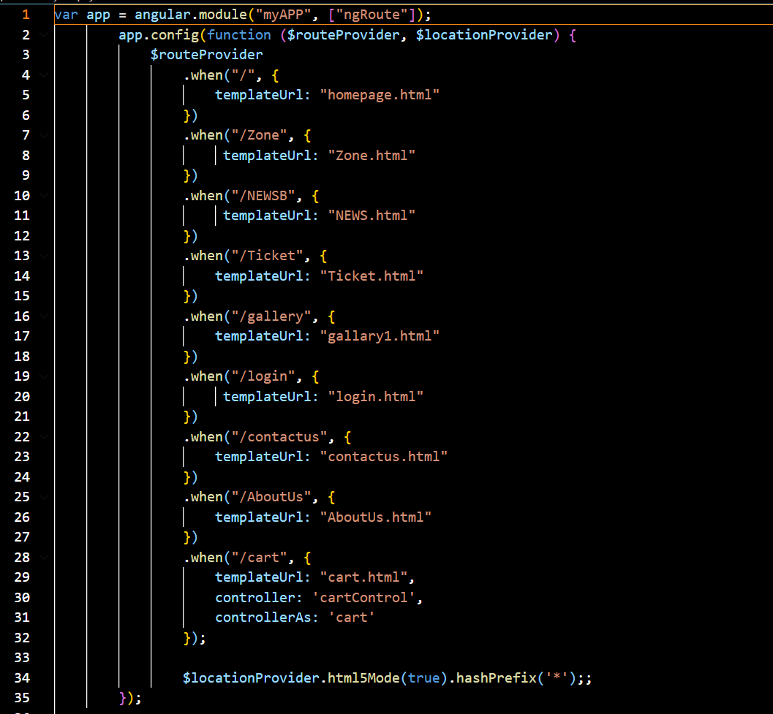

### **2. Cart ticket**

1. Description

This script is used to order ticket and cart.

1. Screen shot

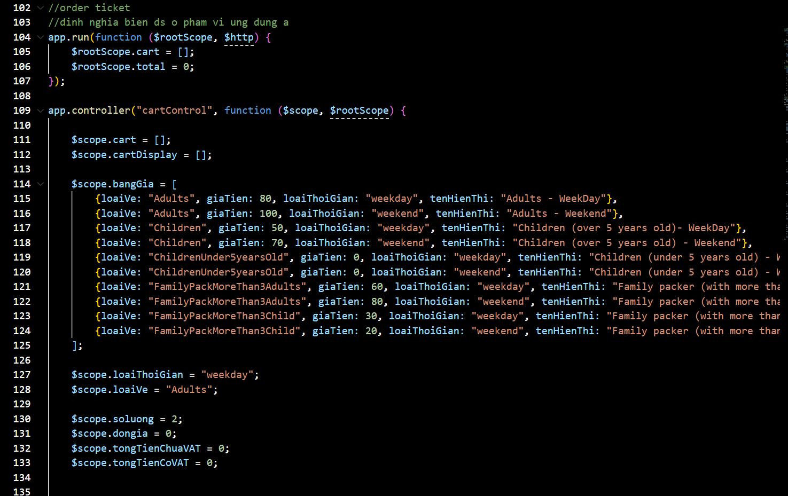

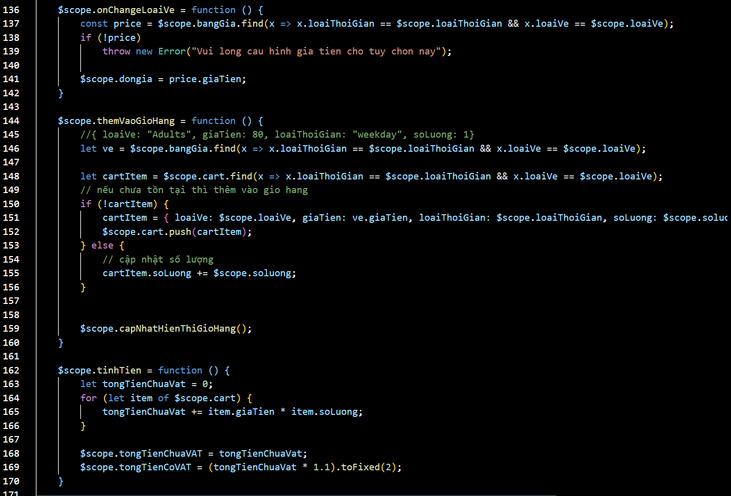

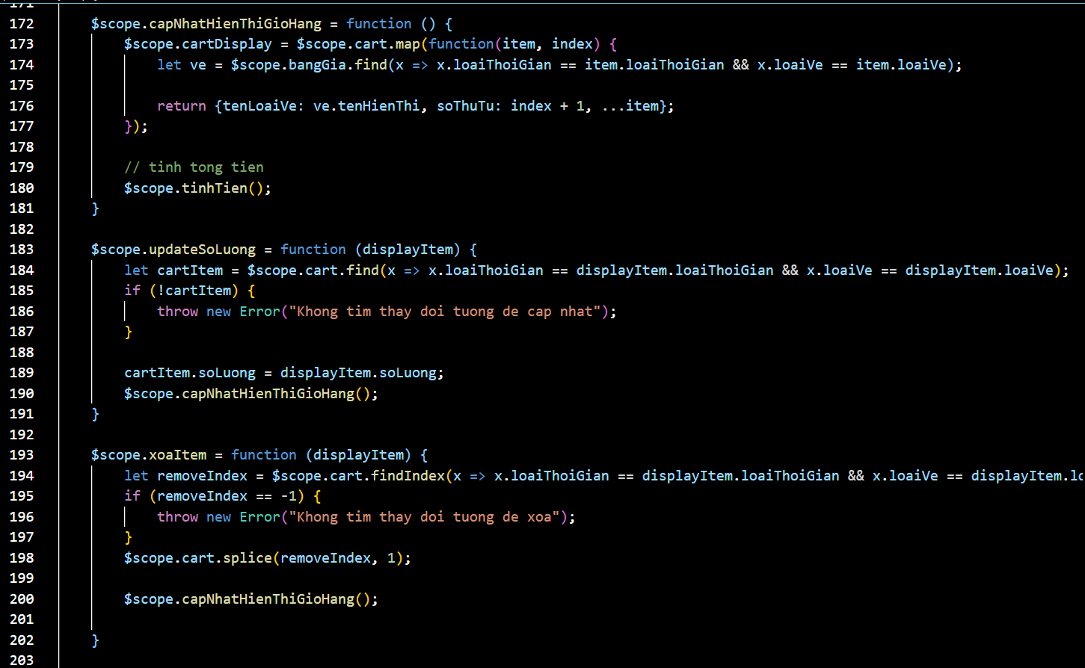

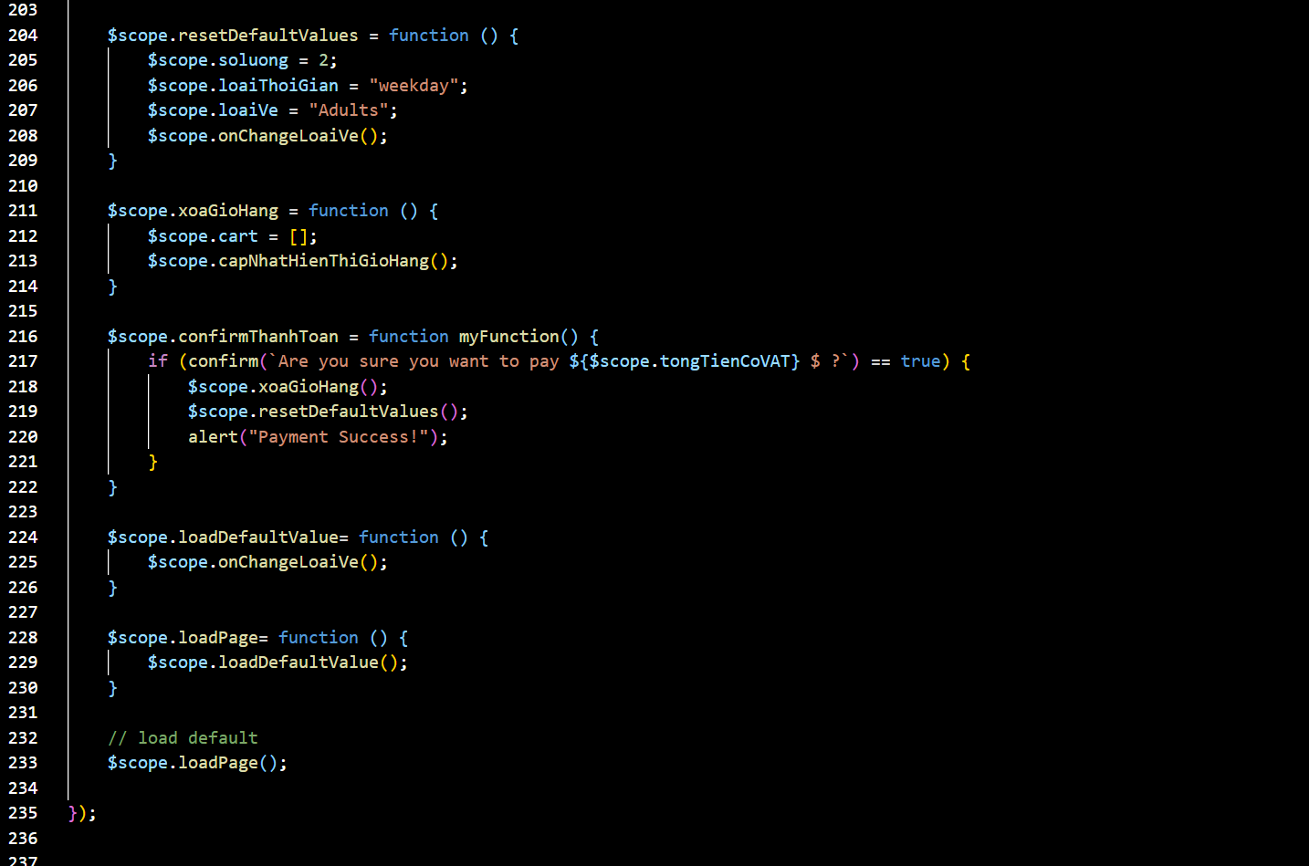

### **3. Contact Us JS**

a) Description

This script used for contact with us.   
b) Screen shot

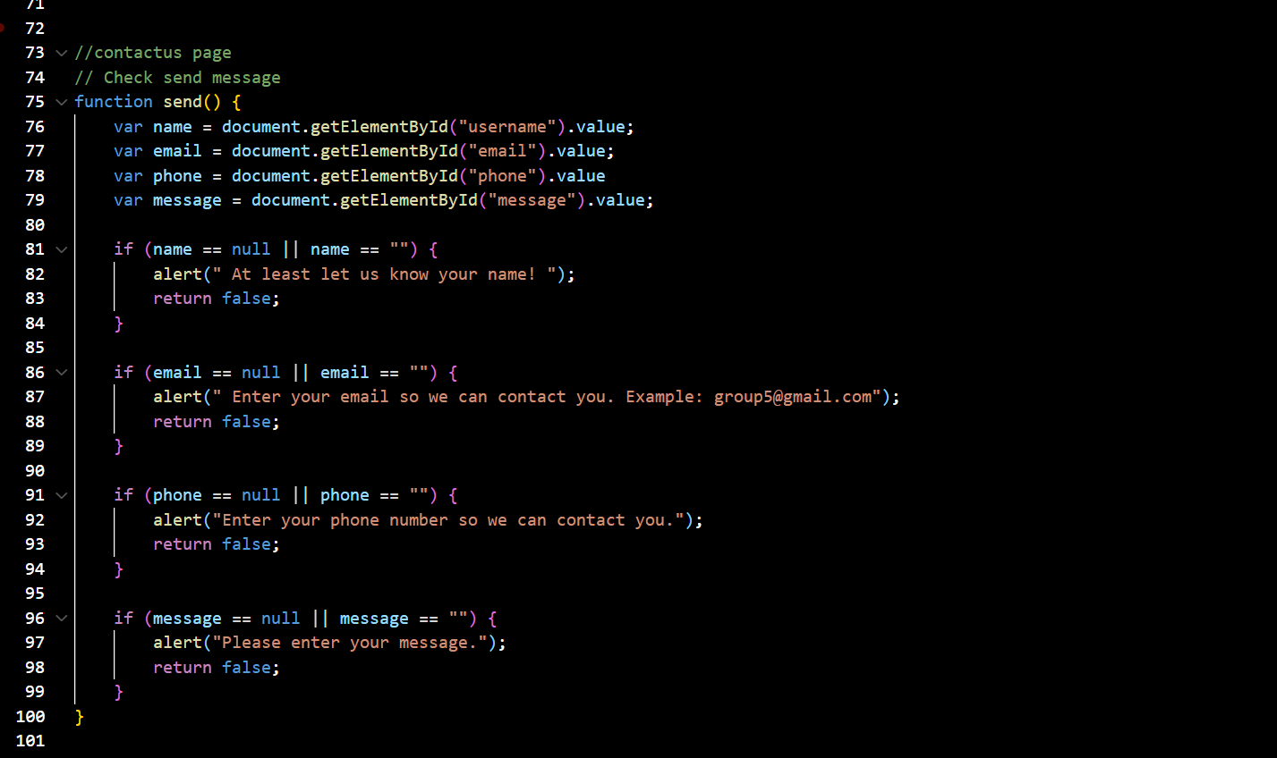

### **4. Create Account/Sign-in Javascript**

a) Description

This script used for member registration and login in the website.   
b) Screen shot

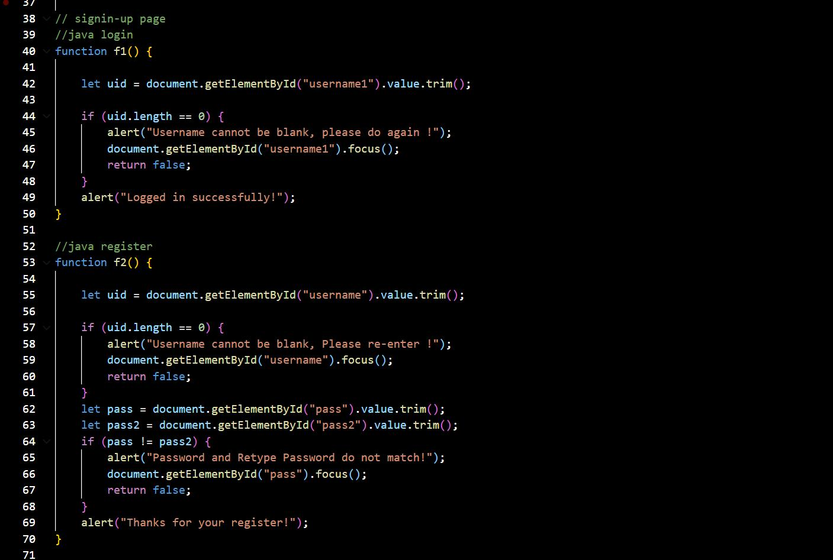

# TASK SHEET REVIEW 3

|  |  |  |  |  |  |  |  |
| --- | --- | --- | --- | --- | --- | --- | --- |
| **Project Ref. No.:**  **eP/Advertisement Portal**  **Management**  **System/01** | | **Project Title:** | **Activity**  **Plan**  **Prepared By:** | **Date of Preparation of Activity Plan:** | | | |
| **Sr. No.** | **Task** | **Actual**  **Start**  **Date** | **Actual Days** | **Team**  **Mate**  **Names** | **Status** |
| 1 | Index Page | Merciado Park | All | 01-Jun-23 | 8 | Tấn | Completed |
| 2 | Home Page | 03-Jun-23 | 2 | Quí | Completed |
| 3 | Zone | 11-Jun-23 | 3 | Tấn | Completed |
| 4 | News | 05-Jun-23 | 5 | Minh | Completed |
| 5 | Ticket | 07-Jun-23 | 2 | Minh | Completed |
| 6 | Gallery | 08-Jun-23 | 2 | Quí | Completed |
| 7 | About Us | 10-Jun-23 | 4 | Quí | Completed |
| 8 | Contact Us | 10-Jun-23 | 1 | Minh | Completed |
| 9 | Sign in/Sign up | 13-Jun-23 | 1 | Tấn | Completed |
| 10 | Java Script | 15-Jun-23 | 20 | All | Completed |
|  |  |  |  |  |  |

|  |  |
| --- | --- |
| **Date:** |  |
| Signature of Instructor:  **Ms. Le Mong Thuy** | Signature of Team Leader:  **Vo Hong Tan** |